December 2019 Newsletter

Stay Up to Date! Patient education is extremely important to us at ______________. We are excited to help provide you with the most up to date women’s health topics in our monthly patient newsletter. We will be periodically letting you know about happenings at our office, women’s health issues and sharing family friendly recipes.

This month’s newsletter topics include:
- Stress Less this Holiday
- Insert Special or VR device info here
- Reasons to get “social” with us
- Healthy Holiday Zucchini Bread

(PAGE BREAK LINE)



We all know that the winter holiday season can be stressful. There are added expenses related to gift-buying, entertaining, and travel; an added layer of expectation, (some might say dread), that the festivities will live up to the ideal we have in our heads; and the very good chance that we’ll come down with a case of the sniffles or worse just to complicate the whole picture. As we carry on through the joys and challenges of the season, we need to take stock of how stress is impacting our lives and strategize for better ways to manage stress this holiday season.
Women overall are more likely to report feeling the symptoms of stress than men, including feeling tense and irritable, being highly distractible, having difficulty making decisions, experiencing frequent mood swings, and generally feeling overwhelmed.
Perhaps it’s no wonder. Women are programmed to be caretakers, which can lead to fulfilling others needs before your own. Women are more vulnerable to feeling selfish, or feeling guilty about saying no to others requests. More women than men have both a career outside the home and are struggling to juggle traditional responsibilities like childrearing and homemaking after hours. Striving to compete in a professional environment and simultaneously trying to embody a more traditional female ideal can take a heavy toll. Add to all of this the fact that as women progress through life’s stages, hormonal changes that result from premenstrual, postpartum, and menopause can affect a woman’s chemical vulnerability to stress and depression. It’s a lot to think about and manage.
Stress is inevitable but planning for how you will manage stress is key to staying healthy and not letting the ups and downs of life negatively impact your health.
Looking ahead to 2020, here are some key ways to relieve stress.
- Learn to say “no” without feeling guilty. Recognize that you have a right to say no without a lengthy justification. “I am sorry, but my plate is full” is often explanation enough.
- Take time to “care” for yourself. Dance, take a bath, or a walk; write in a journal or listen to relaxation tables; meet with a friend; read or listen to music; nap; do breathing exercises and learn to meditate. Simply stretch. Stop and reflect. When you start to feel harried and overwhelmed, do your best to slow down, breathe and give yourself some added attention.
- Don’t try to be all things to all people. Delegate when necessary. Ask for help.

The hardest part for many women is the feeling that they should “do it all.” The pressure to succeed in a professional life, to be a great mother and wife, to be a loving friend, daughter, and sibling, combined with the fear of being considered selfish can create a perfect storm of stress that can lead to high blood pressure, depression, heart attack and stroke.
So, for 2020, talk with your physician about ways that you can protect yourself with stress-relieving strategies that will soothe your state of mind, and improve your overall health.

(PAGE BREAK LINE)

Insert Special or VR device info here

(PAGE BREAK LINE)



We're always giving our patients on Facebook a reason to "Like" our page. Whether it's our educational updates, fun staff photos or something light-hearted to get you through the day, we do our best to keep our Facebook family in the know. Join us on Facebook today!

Insert button with link to Facebook page

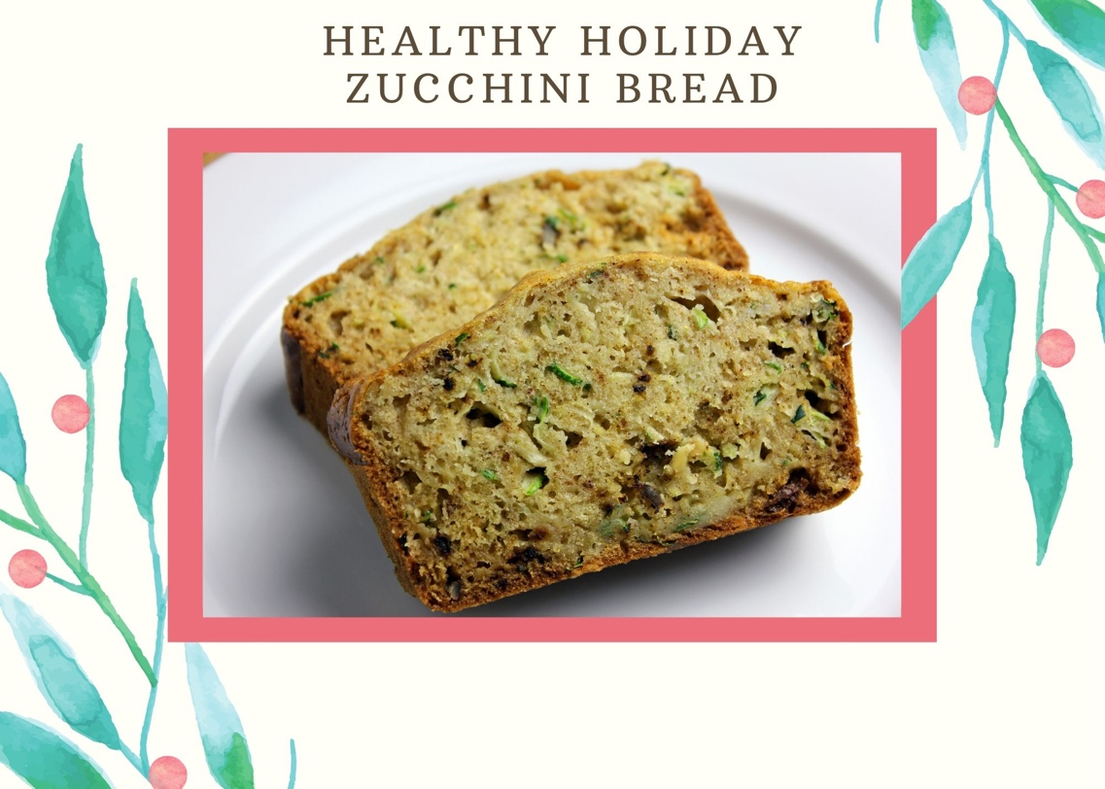

Try this healthier take on zucchini bread for your next holiday brunch.
It’s rich with a moist crumb just like the less healthy versions of this comfort food, but it’s made with wholesome ingredients.
Applesauce and coconut oil give it great texture and a touch of sweetness. Even though it’s better for you this zucchini bread still considered a treat, so don’t overdo it.
Leftover slices can be wrapped individually and stored in the freezer for future meals.

Ingredients
- Nonstick cooking spray
- 6 large egg whites
- ¼ cup melted coconut oil
- ½ cup unsweetened applesauce
- ⅓ cup sugar
- 2 tsp. vanilla extract
- ¾ cups all-purpose flour
- 1¾ cups whole wheat flour
- 1 tsp. baking powder
- 1 tsp. baking soda
- ¾ tsp. sea salt
- 3 tsp. ground cinnamon
- 2½ cups grated zucchini
- ½ cup chopped raw walnuts

Instructions
- Preheat oven to 350° F.
- Lightly coat two 9 x 5-inch loaf pans with spray.
- Combine egg whites, oil, applesauce, sugar, and extract in a large bowl. Set aside.
- Combine all-purpose flour, whole wheat flour, baking powder, baking soda, salt, and cinnamon in a medium bowl; mix well.
- Add flour mixture to egg mixture; mix until just blended.
- Fold in zucchini and walnuts; mix until just blended.
- Divide batter evenly between the two pans.
- Bake for 45 to 50 minutes, or until golden brown and tester inserted into the center comes out clean.
- Cool bread in pans for 5 to 10 minutes, remove from pans and transfer to rack; cool completely.

Also try this yummy Gluten-Free Banana Bread recipe!

