September Newsletter (OBGYN)

Stay Up to Date! Patient education is extremely important to us at ______________. We are excited to help provide you with the most up to date women’s health topics in our monthly patient newsletter. We will be periodically letting you know about happenings at our office, health issues and sharing family friendly recipes.

This month’s newsletter topics include:
- September is Menopause Awareness Month
- Ovarian Cancer Awareness Month
- 23 Easy Breakfast Ideas for Kids

(PAGE BREAK LINE)
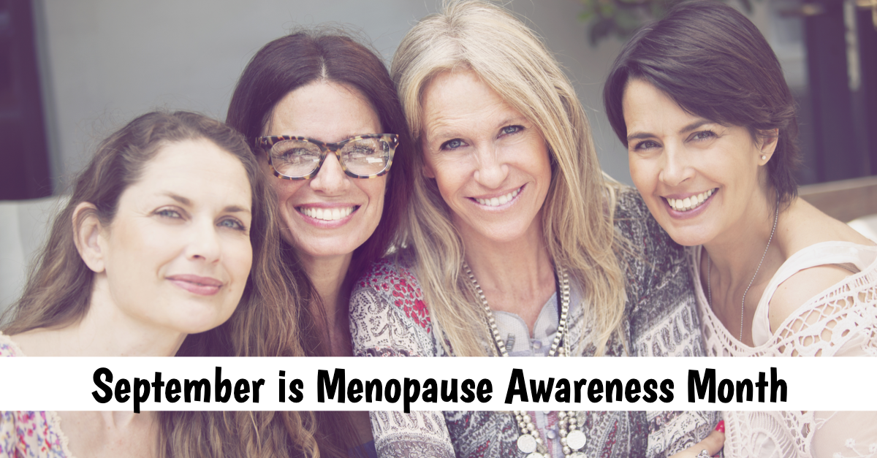

September is Menopause Awareness Month. Even if you’re not in menopause, you probably know someone who is dealing with it. You may have seen their ups and downs.

When does Menopause begin?
Menopause usually begins around the ages of 51-52. Typically, if a woman has not had a menstrual cycle over the course of a year, she is in menopause.

What are some “typical” Menopause symptoms?
The most common symptom experienced by 80 percent of women during menopause are hot flashes (daytime) or night sweats. Some women may also experience muscle and joint pain (arthralgia), mood swings, “brain fog,” loss of libido and weight gain (to name a few). Many women begin to develop insulin resistance and diabetes, osteoporosis and arthritis; all caused by hormonal deficiencies. Intimacy can become painful due to vaginal dryness.

How is it clinically proven that I am in Menopause?
We treat the WHOLE patient as every patient is different and has different needs. Among other tests, we order a full thyroid and hormone panel INCLUDING testosterone, estradiol and follicle-stimulating hormone (FSH).

What are proven solutions to relieving the symptoms of Menopause?
After menopause, hormone replacement therapy (HRT) is often prescribed to resupply the body with the hormones it no longer produces. Discuss this with your doctor. As with any medication, there are risks and benefits, and each woman should decide if HRT is the right choice for her.

For many women that are suffering from the painful symptoms of menopause including dryness, atrophy and pain with intimacy, [NAME OF DEVICE] can be an excellent alternative to hormones. The [NAME OF DEVICE] is appropriate for any female who is experiencing symptoms after menopause, hysterectomy or breast cancer treatments. This therapy is particularly well suited for patients who cannot use estrogen therapy, prefer to avoid estrogen therapy, or who have persistent symptoms despite estrogen therapy.

If you are experiencing these symptoms, call XXX-XXX-XXXX to schedule a consultation to see if [NAME OF DEVICE] is right for you.

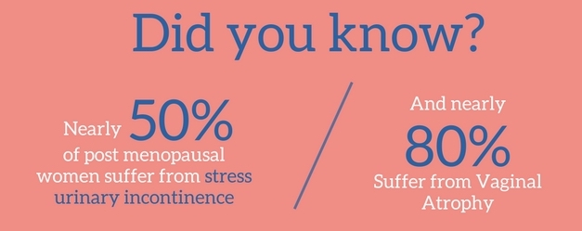

(PAGE BREAK LINE)

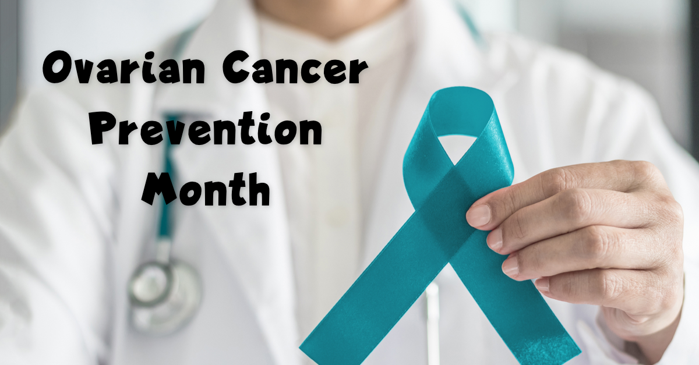

Ovarian Cancer is one of the most deadly women's cancers. Each year, approximately 21,980 women will be diagnosed with ovarian cancer.
This cancer typically occurs in women in their fifties and sixties with the median age being 63. Many women who are diagnosed with Ovarian cancer have a genetic history that may include carrying the BRCA mutation gene and having a strong family history of ovarian cancer.
Unfortunately, many women don't seek help until the disease has begun to spread, but if detected at its earliest stage, the five-year survival rate is more than 93%. The symptoms of ovarian cancer are often subtle and easily confused with other ailments.
Symptoms may include:
• Bloating
• Pelvic or Abdominal pain
• Difficulty eating or feeling full quickly
• Urinary urgency or frequency

Other symptoms may include:

• Nausea, indigestion, gas, constipation or diarrhea
• Extreme fatigue
• Shortness of breath
• Backaches
There is no adequate screening test of ovarian cancer at this time which is one of the reasons that this cancer is often discovered in later stages.
Talk to our office if symptoms last more than 2-3 weeks.

(PAGE BREAK LINE)



Kids need to eat, especially breakfast. Often deemed the most important meal of the day, breakfast fuels the body to keep them alert and focused throughout the day. But getting kids to eat something before school can be a challenge. That’s where easy breakfast ideas come in handy.

Get the Recipes (create button that links to https://tasty.co/article/deenashanker/healthy-easy-breakfasts-your-kids-will-love )

